Comprehensive Revival of Millets Program

Tribal areas

**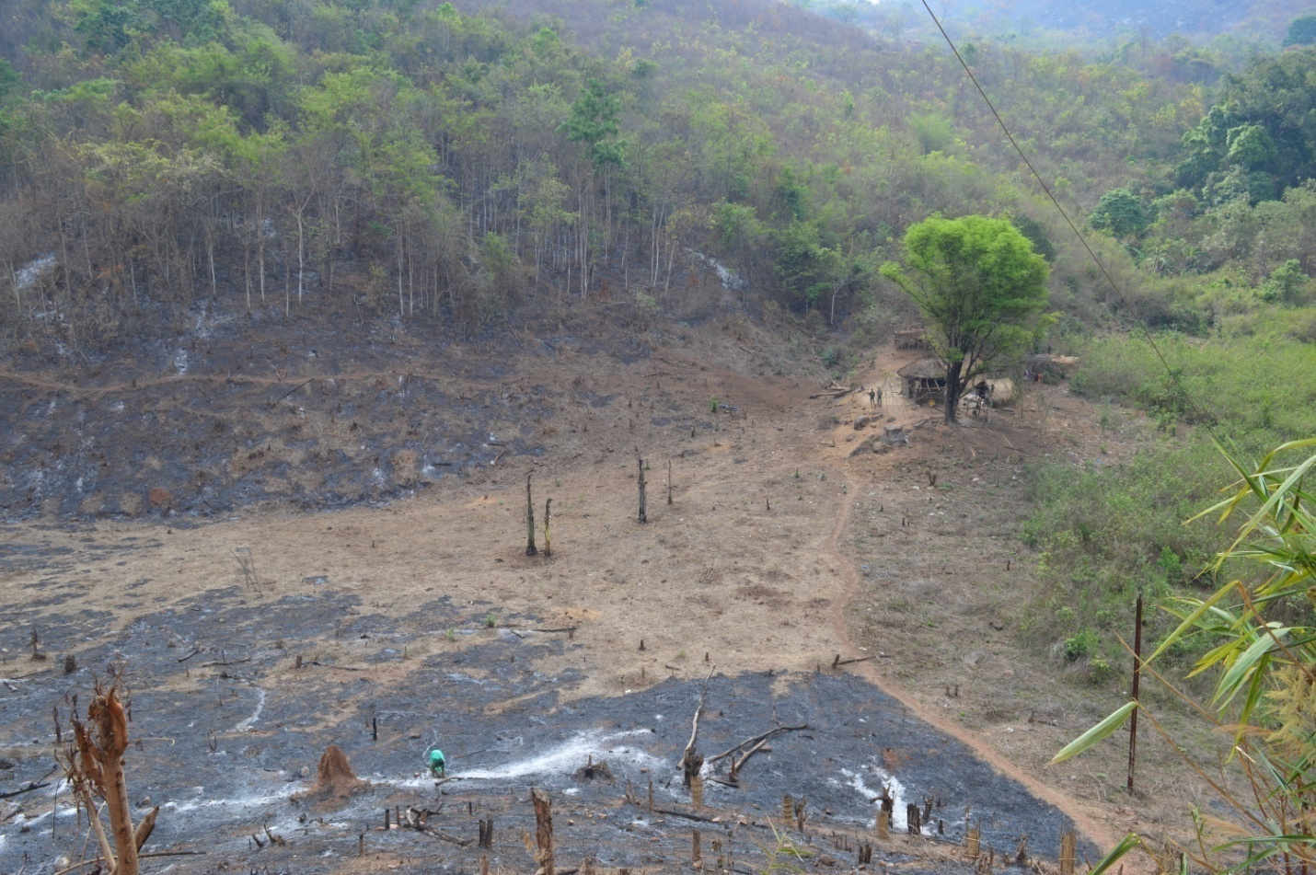**

Narrative Report

**Reporting Period : February to May 15th, 2016**

**Name of the NGO : Laya**

**District : East Godavari**

**Mandal Allocated : Y.Ramavaram**

PART-1

Preparation for the Program Initiation, preparedness for Khariff 2016, in particular

A.1 Operational Area in Y.Ramavaram Mandal

**A.1.1 Identified 10 Panchayats and Villages based on potential for millets promotion**

|  |  |  |  |  |
| --- | --- | --- | --- | --- |
| **Boddagandi** | **Daragedda** | **Gurthedu** | **Pathakota** | **Kaniwada** |
| **22 Villages** | **10 Villages** | **7 villages** | **19 villages** | **10 Villages** |
| **GP1** | **GP2** | **GP3** | **GP4** | **GP5** |
| Boddagandi | Daragedda | Gurthedu | Pathakota | Kanivada |
| Boddumamidi | Lingavaram | Allurigedda | Thangedukota | Vootlabanda |
| Mangampadu | Babbilova | Murikilanka | Singanakota | Jalagalova |
| Marriguda | Poolova | G.Vattigedda | Koppulakota | Jajivalasa |
| Bachaluru | Polamanugondi | Edlakonda | Ganganuru | Gandrallu |
| Antilova | Koramatigondi | Kadarikota | Chanaganuru | Peddalova(H) |
| Nagalova | Buradavalasa | Kothuru | Pulimetala | Kondavejuwada |
| Kallepugonda | Irlavada |  | Kothapakalu | Panasalova |
| Rakota | Busikota |  | Karnikota | Gitumamidi |
| D. Mamidivada | Dumpavalasa |  | Revadikota | Ch.Pakalu |
| Chaparai |  |  | Pulusumamidilanka |  |
| Gondikota |  |  | Kinnerla |  |
| Jandakupi |  |  | Gandhamuru(H) |  |
| Rajucamp |  |  | Gudlawada(H) |  |
| Babunagar |  |  | Kinkinirayi(H) |  |
| Buradakota |  |  | Palusurimetta(H) |  |
| Hampodhar |  |  | Tummichelu(H) |  |
| Narasingapur |  |  | Pedakonda(H) |  |
| Navaguda |  |  | Rachametta(H) |  |
| Sindhuwada |  |  |  |  |
| Pulikonda |  |  |  |  |
| Reddinagaram |  |  |  |  |
| **Chinthalapudi** | **Dalipadu** | **Chamagedda** | **K.Yerragonda** | **Yerramreddipalem** |
| **7 Villages** | **7 Villages** | **8 Villages** | **6 Villages** | **5 Villages** |
| **GP6** | **GP7** | **GP8** | **GP9** | **GP10** |
| Chinthalapudi | Dalipadu | Chamagedda | K. Yerragonda | Yerramreddipalem |
| Bheemudugadda | Pulusumamidi | Singavaram | Chendurthi | Nuvvugantipalem |
| Boddagunta | Bonangipalem | Nellikota | Simhadripalem | Mulasalapalem |
| Chinta Koyya | Munagalapudi | Buradakota | Chinavulempadu | Gandempalle |
| Bangarubandalu | Annampalem | Jangalathota | Regadipalem | Boddapalle |
| Valasa | Gummarapalem | Dadalikavada | Vanamamidigondi |  |
| Kothuru | Tumikelapadu | Ramulakonda |  |  |
|  |  | Bandigedda |  |  |

**A.1.2** MAP OF Y.RAMAVARAM MANDAL WITH PANCHAYATS SELECTED FOR COMPREHENSIVE REVIVAL OF MILLETS PROGRAMME

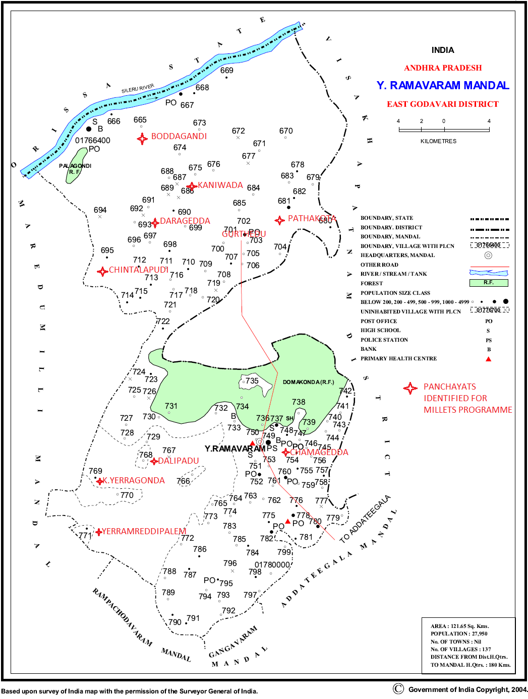

**A.1.3 Process of selection of the Gram Panchayats for Comprehensive revival of millets programme**

Laya has organized a meeting with our staff member, 4surpanches and some of key persons from the community to identify the Grama Panchayats for comprehensive revival of millets as we finalized the 10 GP’s following criteria

1. We have prioritized the Panchayats where potential is more
2. Hilly and undulated landscape areas
3. Where the Panchayats has high tribal population (Total 92.33% tribal population living in the selected Panchayat )
4. Till 1990 this area is millets cultivation hub and habit of eating millets in their regular diet
5. Highly degraded soils in “Podu lands”
6. Millets grown under traditional methods
7. This area has own millets farming system
8. There is shift in cropping pattern from millets to pulses in upper part of the Mandal and cotton & cashew in lower part of the Mandal.

**Advantages of selecting these Grama Panchayats:**

The terrain very much suitable to millets cropping system and farmers are very interested in revival of millets in their cropping system and also in their diet, the lower part of the Mandal farmers in debt with cotton cultivation and it implication in pricing since last 6 year there no any change in price of the cotton, farmers are looking for alternative crops to replace the cotton.

As inter crop of millets in cashew gardens are more preferable because there is no much investment in millets cultivation

The community is ready to adopt new technologies like SRI, line sowing, mixed cropping system with pulses and cereals.

And Laya has long term association with these selected “Gram Panchayats” has good Rapport with the community for scaling up cultivation area, establish processing units and marketing

Climate conditions are favorable to millets cropping system the annual rainfall is 1200 mm, red loamy soils are more in these Panchayats, and temperature in cropping season is 16 to 30 degree centigrade

There is irrigation source in some pockets for critical irrigation and some of the farmers have already pump sets.

## A.2 Key Staff details for this Millets Program

|  |  |  |  |  |  |  |  |  |  |
| --- | --- | --- | --- | --- | --- | --- | --- | --- | --- |
| **Sno** | **Role** | **Name** | **Designation** | **Education** | **Full / Part time** | **Contact Details** | | | Are they joined in Siridhanyam google group  (Yes / No) |
| **Mobile** | **Email** | **WhatsApp** |
| 1 | Overall Decision making related to the program | Dr. Nafisa Goga D’souza | Executive Director | M.A Social work PhD | Full time | +91 891 2735332,  2526663 | [layarc@gmail.com](mailto:layarc@gmail.com) |  | No |
| 2 | Point Person to LTA / ATMA | K.Koteswara Rao | NRM unit Coordinator | M.A Sociology; Certificate course in watershed development and agriculture extension management (CRIDA & Manage 1997) | Full time | 9440541298 | [laya.adt@gmail.com](mailto:laya.adt@gmail.com) | 9440541298 | Yes |
| 3 | Full time field coordinator for the Mandal | B.Chakrababu | NRM unit field coordinator | B.A. | Full time | 9494544569 | [bchakrababu2010@gmail.com](mailto:bchakrababu2010@gmail.com) | 9494544569 |  |
| 4 | Full time agriculture extension person | Sagina Krishna Padal | Agriculture extension manager | Diploma in Agriculture | Full time | 8330947430 | [saginakrishnapadal@gmail.com](mailto:saginakrishnapadal@gmail.com) | 8330947430 | Yes |
| 4 | Data management/ Reports preparation | Present: K.Koteswara Rao | NRM unit Coordinator |  | In Future full time staff will be appointed | 9440541298 | [kingkoti2002@gmail.com](mailto:kingkoti2002@gmail.com) | 9440541298 | No |
| **Other staff of NGO who may be involved in Trainings/ Programs** | | | |  |  |  |  |  |  |
| 5 |  | A.Padmavathi | Women empowerment unit field coordinator | B.A | Full time | 9492312925 | [padmavathiakula6@gmail.com](mailto:padmavathiakula6@gmail.com) | Nil | No |
| 6 |  | K.Sarojini | NRM unit Field Assistant | Inter mediate | Part time | Nil | Nil | Nil | No |
| 7 |  | K.Rajyalakshmi | NRM unit Field Assistant | Inter mediate | Part time | 9494621038 | [kakurirajyalaxmi@gmail.com](mailto:kakurirajyalaxmi@gmail.com) | Nil | No |
| 8 |  | M.Suresh Reddy | NRM unit Field Assistant | **Inter mediate** | Part time | 9180335691 | [murlasureshreddy@gmail.com](mailto:murlasureshreddy@gmail.com) | Nil | No |

|  |  |  |  |
| --- | --- | --- | --- |
| nafisa-Dsoza | FB_IMG_1445325558055 | 20151104_083622 | Padma Passport size |
| **Dr. Nafisa D’Souza** | **K.Koteswara Rao** | **B.Chakrababu** | **A.Padmavathi** |
| **Executive Director** | **NRM unit coordinator** | **NRM unit Field Coordinator** | **Women Empowerment unit coordinator** |

|  |  |  |  |
| --- | --- | --- | --- |
| C:\Users\King Koti\AppData\Local\Microsoft\Windows\Temporary Internet Files\Content.Word\DSC_2083.jpg | 20160305_115754 | DSC_2077 | DSC_1769 |
| **Sagina Krishna Padal** | **K.Sarojini** | **K.Rajyalakshmi** | **M.Suresh Reddy** |
| **Agriculture Extension manager** | **NRM unit Field Assistant** | **NRM unit Field Assistant** | **NRM unit Field Assistant** |

# A.3 GP Level Participatory Situation Analysis

Annexures:

3.1 List of Community Organisations in the selected GPs and their brief status (see Table in Annexures)

|  |  |
| --- | --- |
| * **Nodal CBO** | 1 |
| * **Which is the Nodal CBO for the program** | MACS |
| * **Name** | The Boddagandi Adivasi Multipurpose Mutually Aided Co operative Society Limited |
| * **Type of CBO** | Mutually Aided Co operative Society |
| * **Background of the CBO (Describe)**   ***(When it has started? What is the purpose? Who are the promoters)*** | The MACS has established in 2008 to address the marketing and credit issues in the Y.Ramavaram Mandal upper part area, the tribal farmers and women activists(tribals) were the promoters |
| * **Describe the process you have followed for Participatory Situation Analysis** | Followed the Social analysis system and PRA tools like,transact walk ,social mapping ,Resource mapping ,trend analysis, focus group discussions and matrix by involving with different stakeholders |
| * **Data from situation analysis and action plan are merged and presented in PART – 2** |  |

|  |  |
| --- | --- |
| * **Nodal CBO** | 2 |
| * **Which is the Nodal CBO for the program** | Society |
| * **Name** | Adivasi Girijana Abhivrudhi Samkshema Seva Sangam |
| * **Type of CBO** | Trial Community development Society |
| * **Background of the CBO (Describe)**   ***(When it has started? What is the purpose? Who are the promoters)*** | The CBO has established in 2006 to address the food security and agriculture issues in the Y.Ramavaram Mandal lower part area, the tribal farmers and women activists(tribals) were the promoters, the CBO is constantly working on Agriculture in this area |
| * **Describe the process you have followed for Participatory Situation Analysis** | Followed the Social analysis system and PRA tools like,transact walk ,social mapping ,Resource mapping ,trend analysis, focus group discussions and matrix by involving with different stakeholders |
| * **Data from situation analysis and action plan are merged and presented in PART – 2** |  |

# B.1. Mandal Level Stakeholders Involvement

B.1. Meetings conducted at Mandal level with different stakeholders

|  |  |  |  |  |  |
| --- | --- | --- | --- | --- | --- |
| **S.No.** | **Event Name** | **Date** | **Location** | **Participants** | **Issues/ Themes discussed** |
| 1 | Meeting with Farmers groups representatives | 13.02.16 | Gummaripalem | 45 (Male-30,Female-15) | * What are the problems in agriculture at present * How can we overcome from the present situation * What can be done in future in agriculture * Option for include millets in present cropping system as backup |
| 2 | Meeting with owners of Rice de-husking mills | 21.02.16 | Pathakota | 5 (only male) | * What is current situation of customer of Paddy farmers * How much income they earning from milling of paddy * Is there any scope for establish millet processing mills in their business * What are the mills required for millet processing * Supply chain analysis |
| 3 | Meeting with Small hotel owners | 18.03.16 | Mangampadu | 12 (Male-8,Female-4) | * What are the Tiffin’s at present sold in their hotels * Can they adopt millets based Tiffin’s in their menu * Cost benefit analysis * How can they access the raw materials for preparation of kind of Tiffin’s * They are interested in learning millets based recipes |
| 4 | One training on millets production and value addition with collaboration of ATMA,EGDT | 26-03-16 | Rampachodavaram | 88 farmers (Male-74,Female-14) from 4 mandals& 25 officials and NGO representatives | * Aspects of increase Production of millets * Constrains in millets cultivation * Marketing of millets * Value added products with millets * Millets based recipes |

B.2. What are the issues discussed / emerged during the meetings at Mandal level?

* In the first meeting held at Gummaripalem village of Dalipadu Panchayat of Y.Ramavaram Mandal with farmers groups representative on 13.02.16.The present cropping system is not meeting their food requirements, the farmers shifted to commercial crops cultivation since 3 decades like tobacco, cotton, tapioca. In beginning it was given good income but over period of time they are not giving good income and also soils are eroded the climate is not supporting at present. The farmers now in dilemma whether they can shift to their traditional cropping system if yes the seeds are not available like earlier if there are seeds around they can cultivate the traditional crops like Ganti, Sama, Korra, Chodi, Jonna and Mokkajonna and second crop pulses like horse gram, cowpea etc,.. this is scenario of Y.Ramavaram Mandal lower part Panchayats situation, where as upper part Panchayats the Konda Podu lands are converting in to broom grass cultivation and horticulture plantations and most of the Podu lands are kept fallow due to laborious work, some of the slope lands using for Rajma beans cultivation these crops giving good cash income but if rains are not enough during crop season the investment and seed are loss this happening in recent periods since 5 years the crop losses is very high, the situation paddy cultivation under rain fed system is facing several problems, the farmers are come forward to take up millets cropping system and strengthening system with innovations
* The women farmers are shared their ideas to improve the intake of millets in their household level, need de-husking mills and flour mills at their nearby areas if these machine available we can process our millets and will consume easily now a days the women are not much interest in pounding millets rice, Ragi flour can make easily with our traditional tools like “Tiragali” the women are interested to learn different kind of recipes
* Meeting with entrepreneurs held at Pathakota village of Y.Ramavaram Mandal, rice de-husking mills are easily available nearby areas and maintenance also easy. We don’t know about millets de husking mills where it available and cost of the machines if the machines are made available nearby areas we can try to purchase them and install with our paddy hullers. If we kept machines the cultivation may increases and we will get more income from the millets processing
* Hoteliers meeting in Mangampadu village: At present in the hotels making idly and Dosa with black gram, rice ravva, rice flour and Maida. If we know the preparation of items with millets and if ready to cook items available in the market we are interested in making millets based items.
* We are planning organize a meeting with all stake holders on 23rd May 2016 at Y.Ramavaram MPDO office.
* In the Rampachodavaram meeting PO ITDA announced that ITDA will purchase the RAGI and other millets ready cook items for Ashram schools children to provide healthy food

# B.3 FA met the following officials at the Mandal Level and briefed about the program.

(*Please fill in the officials)*

|  |  |  |  |  |
| --- | --- | --- | --- | --- |
| **S.No.** | **Official** | **Department** | **Name** | **Did the FA meet her/him and briefed about the program? Yes/ No** |
| 1 | Agricultural Officer | Dept of Agriculture | Sri. Padala Gandhi | Yes |
| 2 | Block Technical Officer | ATMA | Sri. Neeli Baburao | Yes |
| 3 | ICDS supervisor | ICDS | MsVaralakshmi | Yes |
| 4 | MPDO | Mandal Praja Parishad | Sri K.Bapannadora | Yes |
| 5 | MPEO’s | Dept of Agriculture | Sri Kikuri Thammayya | Yes |
| 6 | APO | MGNREGS | Sri.Naidu | Yes |
| 7 | MPP | Mandal Praja Parishad | Smt Karra. Venkatalakshmi | Yes |
| 8 | MEO | Department of Education | Sri.Prasad Babu | Yes |
| 9 | APM | SERP(Velugu) | Sri.Durgaparasad | Yes |
| 10 | Principal Scientist | KVK,Pandirimamidi | Dr.Srinivas | Yes |

## C. Baseline Surveys

Any attempts done on this? If so describe. (A program level baseline is yet to be initiated by the LTA)

* Existing GP level Millets cultivation and scope for increase the area of cultivation
* Household level millets consumption
* Seed availability for millets cultivation
* Yield per acre of present millet cropping system
* Traders involved in millets marketing
* Small hotels and shops millets usage

PART - 2

Production related (Drawing from Baselines and Action Plans)

**A. Millet - Crop Systems in the Area**

1. Brief description of the process followed and observations

**Process followed:**

We facilitated to organize GP level meetings with old farmers, youth farmers and women farmers in 10 Grama Panchayats, conducted PRA at GP level, and focused group discussions with different community, age and gender groups to get first hand information about millets crop system

**Observations:**

* **The community wise millets crop system**

1. Kondareddies, Khondh, Porja communities are following same cropping system (Mixed millets in Kondapodu and metta lands sama alone in the second year Podu lands)
2. Koyas and Konda kammara community they are use to cultivate in metta lands only
3. Valmiki community does not follow any millets cropping system

* Types of Millets existing in the GPs

1. 30 years ago 6 to 7 types of millets with varietal differences (Korra,Jonna,Sama, Bontha,Variga, Chodi, Ganti)
2. At present Sama,Ragi mostly, Korra and Jonna and Ganti decreased in cultivation in hilltop Panchayats
3. Only few farmers in 4 Panchayats are cultivating Ragi for their consumption the total millets crop system disappeared from the area

* Millets consumption at household level

1. Upper part of the Mandal Panchayats Kaniwada,Chinthalapudi,Dargedda,Boddagandi 30% of the households having at least 4 meals in a week with millets Ragi ambali is regular, 40% of the households having at least 2 meals in a week with millets Ragi ambali is regular, 30% of the households not consuming millets but few families are consuming Ragi ambali sometimes only, Pathakota and Gurthedu panchayats 50% of the households having millets and Ragi ambali the remaining 50% households ar naot having millets in their food system
2. Lower part of the Panchayats are 10 % of the households consuming 2 meals in the week with sama and ragi the 90 % of the households not having millets in their food system

* Sale of Millets is no practice whatever produce the households getting they are kept for households consumption only in all Panchayats

2. Types of Millet Crop Systems (*give description)*

|  |  |  |  |  |
| --- | --- | --- | --- | --- |
| **Crop System Code** | **Type of Land** | **Name of millet Crop Systems** | **Crops** | **Description of the system** |
| 1 | Kondapodu | Mixed millets with Pulses | Ragi, Korra, Ganti, Kandi and Alasanda | New Konda podu 1st year cropping system followed by the farmers |
| 2 | Kondapodu | Sama (Buggiveda) | Sama,Alasanda and Mokkajonna | 2nd year podu sama sown in may wait for rain for sprouts and kandi Jonna will be planted |
| 3 | Chelka podu | Mixed Millets | Sama,Korra,Jonna,Ganti and Ragi sown with Timerelu,Alasanda and Konda kandi | Same as 2nd year podu practice |
| 4 | Metta / Garuvu | Mixed millets with pulses | Ragi, sama,Korra, Ganti, Kandi and Alasanda | Ploughing is needed for seed sowing after summer rains land preparation will be done and seed sowing take place in 1st or 2nd week of th june |
| 5 | Pallamu | Polamu | Paddy | Transplanted and Direct seed sowing |
|  |  |  |  |  |

3. Extent of the Crop Systems

|  |  |  |  |  |  |
| --- | --- | --- | --- | --- | --- |
| **S.No** | **GP** | **Crop System Code (as in the above table)** | **Area (ac) extent**  **10 year ago** | **Area extent in 2015 ( acres)** | **Main reasons for the change** |
| 1 | Pathakota | 1,2,3  4  5 | 530  858  565 | 251  200  645 | Laborious work, PDS rice ,NREGS focus on cash crops |
| 2 | Gurthedu | 1,2,3  4  5 | 480  265  250 | 150  65  250 | Laborious work, PDS rice ,NREGS focus on cash crops |
| 3 | Daragedda | 1,2,3  4  5 | 550  120  320 | 250  20  320 | Laborious work, PDS rice ,NREGS focus on cash crops |
| 4 | Kaniwada | 1,2,3  4  5 | 350  120  65 | 150  20  65 | Laborious work, PDS rice ,NREGS focus on cash crops |
| 5 | Boddagandi | 1,2,3  4  5 | 1500  600  450 | 500  300  450 | Laborious work, PDS rice ,NREGS focus on cash crops |
| 6 | Chinthalapudi | 1,2,3  4  5 | 450  250  250 | 220  100  250 | Laborious work, PDS rice ,NREGS focus on cash crops |
| 7 | Chamagedda | 1,2,3  4  5 | 50  350  350 | Nil  20  350 | Commercial crops less rainfall and PDS  NREGS |
| 8 | Dalipadu | 1,2,3  4  5 | 50  450  350 | 10  0  350 | Commercial crops less rainfall and PDS  NREGS |
| 9 | K.Yerragonda | 1,2,3  4  5 | 25  270  200 | Nil  22  150 | Commercial crops less rainfall and PDS  NREGS |
| 10 | Yerramreddypalem | 1,2,3  4  5 | 50  250  320 | Nil  15  250 | Commercial crops less rainfall and PDS  NREGS |

## B. Khariff Seed Plans (2016)

1. Area seed indents collected from the villages? Yes

2. If *YES*, Summary of the Seed Indent for all villages in the Mandal

|  |  |  |  |  |  |  |  |  |
| --- | --- | --- | --- | --- | --- | --- | --- | --- |
| **S.No** | **Millet Crop** | **Variety**  **(if specified)** | **Area in acres to be taken up** | **No of farmers** | **Seed Requirement in KG’s** | **Seed Source** | | |
| **Pulled locally** | **Purchased outside** | **Need put indent for ARS/IIMR/Agl. Dept** |
| 1 | Ragi | Local | 500 | 450 | 2000 | 1400 | 600 | 0 |
| 2 | Sama | Pedda Sama | 500 | 500 | 2000 | 1000 | 1000 | 0 |
| 3 | Korra | Nakkathoka | 300 | 400 | 900 | 535 | 365 | 0 |
| 4 | Jonna | Thella Jonna | 200 | 400 | 800 | 460 | 265 | 75 |
| 5 | Ganti | Pitta Ganti | 300 | 300 | 1200 | 640 | 560 | 0 |
|  |  | Total | 1800 | **\*2400** | 6900 | 4035 | 2790 | 75 |

## \* Cumulative figure

## C. Mana Vittana Kendram (MVK)

|  |  |  |
| --- | --- | --- |
| **1.** | **Nodal Organisation for Seed Systems / MVK** |  |
|  | * Village | Gummaripalem |
|  | * Gram Panchayat | Dalipadu |
|  | * Latitude | 17.60934717 |
|  | * Longitude | 81.96372435 |
| 2. | **Name of Community Organisation** | Adivasi Girijana Abhivrudhi Samkshema Seva Sangam. Pulusumamidi |
|  | * Type of CBO | Adivasi youth farmed as society |
|  | * Registration Status | Registered under societies act |
|  | * Functioning of the CBO | UNION BANK OF INDIA-ADDATEEGALA  **Account Number 11081 Functional** |
|  | * Does the CBO has any funds of its own? | NO |
|  | * Is this village same as the nodal village identified for procurement by MARKFED (that is to be planned later)? | NO |

1. **Discussion or Events conducted in the GP to select the MVK nodal village / CBO**

|  |  |  |  |
| --- | --- | --- | --- |
| **Sl. No.** | **Event Date** | **Description of the Event** | **Participants** |
| 1 | 3-3-2016 | Pathakota GP PRA and FGD on CRMP | Farmers, Panchayat leaders |
| 2 | 5-3-2016 | Gurthedu GP PRA and FGD on CRMP | Farmers, Panchayat leaders |
| 3 | 6-3-2016 | Daragedda GP PRA and FGD on CRMP | Farmers, Panchayat leaders |
| 4 | 12-3-2016 | Dalipadu GP PRA and FGD on CRMP | Farmers, Panchayat leaders |
| 5 | 15-3-2016 | K.Yerragonda GP PRA and FGD on CRMP | Farmers, Panchayat leaders |
| 6 | 18-3-206 | Boddagandi GP PRA and FGD on CRMP | Farmers, Panchayat leaders |
| 7 | 7-4-2016 | Chamagedda GP PRA and FGD on CRMP | Farmers, Panchayat leaders |
| 8 | 12-04-2016 | Chinthalapudi GP PRA and FGD on CRMP | Farmers, Panchayat leaders |
| 9 | 16-4-2016 | Yerramredipalem GP PRA and FGD on CRMP | Farmers, Panchayat leaders |
| 10 | 22-4-2016 | Kaniwada GP PRA and FGD on CRMP | Farmers, Panchayat leaders |

1. What are the systems of seed production / distribution / exchange arrived at?

Farmers will take seed and cultivate in one season and repay 1:2 ratio (Namu &Sirinamu system) at farmers level and MVK level also adopt same system this is optional and cash purchase

1. How does the Seed Centre earn and pay for its maintenance and services?

Seed centers keep required seed for the next season the remaining seed will be processed and sold out that money keep for maintenance and service of the seed centers

1. Does the Seed Centre have storage space? By when, it can arrange for one?

Yes Mandal level Manavithana Kendram has storage space in Gummaripalem village Laya has one community hall in the village on room 12x10 feet size allocated for seed center, weighing machine storage bins etc need to be arranged

## D. Participatory Varietal Trails

*Preparations done so far?*

1. How are you planning to implement Participatory Varietal Trials?

Indentified progressive farmers in the terrain specific system in Y.Ramavaram Mandal for varietal trials criteria is community, land types, irrigation source, soil nutrient management etc,..

|  |  |  |  |  |  |  |  |
| --- | --- | --- | --- | --- | --- | --- | --- |
| S.No | Panchayat | Village | Farmer Name | Father Name/Husband Name | Community | Land Type | Irrigation source |
|
| 1 | Pathakota | Pathakota | Kondla Kameswara Rao | Bodayya | Kondareddy | Garuvu | Rainfed/strearm |
| 2 | Pathakota | Pathakota | Pathakota Lingareddy | Sambhureddy | Kondareddy | Pallamu | Checkdam |
| 3 | Pathakota | Pathakota | Saramkota Bodireddy | Chembhureddy | Kondareddy | Kondapodu | Rainfed/springs |
| 4 | Daragedda | Dumpavalasa | Chedala Kameswara Rao | Ramireddy | Kondareddy | Kondapodu | Rainfed/springs |
| 5 | Daragedda | Dumpavalasa | Kadabala Kameswara Rao | Rajareddy | Kondareddy | Garuvu | Stream/Pumping |
| 6 | Daragedda | Dumpavalasa | Kondla Koteswara Rao | Kutumbharao | Kondareddy | Pallamu | Checkdam |
| 7 | Boddagandi | Mangampadu | Saramkota Abbaireddy | Narasayya | Kondareddy | Pallamu | Checkdam |
| 8 | Boddagandi | Mangampadu | Marigela Bojjayya | Nadipireddy | Kondareddy | Metta Garuvu | Rainfed/stream |
| 9 | Boddagandi | Mangampadu | Naini Devayya | Mangireddy | Kondareddy | Pallamu | Checkdam |
| 10 | Boddagandi | Boddagandi | Saramkota Borramreddy | Peddareddy | Kondareddy | Kondapodu | Rainfed/stream |
| 12 | Pathakota | Pulusumamidilanka | Pallala Devireddy | Bullireddy | Kondareddy | Pallamu | Checkdam |
| 13 | Pathakota | Pulusumamidilanka | Pallala Pushpamma | Nadipireddy | Kondareddy | Kondapodu | Rainfed/stream |
| 14 | Pathakota | Pulusumamidilanka | Pallala Somireddy | Sambhureddy | Kondareddy | Garuvu | Stream/Pumping |
| 15 | Dalipadu | Pulusumamidilanka | Mulasala Chinnarao | Balayya | Kondareddy | Garuvu | Rainfed/stream |
| 16 | Dalipadu | Burugupalem | Jampa Jogamma | Karraya | Kondareddy | Garuvu | Rainfed |
| 17 | Dalipadu | Burugupalem | Kikuri Abbai | Chinnayya | Kondareddy | Garuvu | Rainfed |
| 18 | Gurthedu | G.Vattigedda | Cheruvuri Somireddy | Ramireddy | Kondareddy | Garuvu | Rainfed/stream |

1. What are the crops /varieties you have planned for trials: No of plots/ size in acres?

|  |  |  |  |  |  |  |  |  |  |
| --- | --- | --- | --- | --- | --- | --- | --- | --- | --- |
| Ganti | | Jonna | | Sama | | Korra | | Ragi | |
| Extent in Acres | Seed in Kgs | Extent in Acres | Seed in Kgs | Extent in Acres | Seed in Kgs | Extent in Acres | Seed in Kgs | Extent in Acres | Seed in Kgs |
| 0.15 | 0.45 | 0.15 | 0.45 | 0.15 | 0.3 | 0.15 | 0.3 | 0.15 | 0.3 |
| 0.15 | 0.45 | 0.15 | 0.45 | 0.15 | 0.3 | 0.15 | 0.3 | 0.15 | 0.3 |
| 0.15 | 0.45 | 0.15 | 0.45 | 0.15 | 0.3 | 0.15 | 0.3 | 0.15 | 0.3 |
| 0.15 | 0.45 | 0.15 | 0.45 | 0.15 | 0.3 | 0.15 | 0.3 | 0.15 | 0.3 |
| 0.15 | 0.45 | 0.15 | 0.45 | 0.15 | 0.3 | 0.15 | 0.3 | 0.15 | 0.3 |
| 0.15 | 0.45 | 0.15 | 0.45 | 0.15 | 0.3 | 0.15 | 0.3 | 0.15 | 0.3 |
| 0.15 | 0.45 | 0.15 | 0.45 | 0.15 | 0.3 | 0.15 | 0.3 | 0.15 | 0.3 |
| 0.15 | 0.45 | 0.15 | 0.45 | 0.15 | 0.3 | 0.15 | 0.3 | 0.15 | 0.3 |
| 0.15 | 0.45 | 0.15 | 0.45 | 0.15 | 0.3 | 0.15 | 0.3 | 0.15 | 0.3 |
| 0.15 | 0.45 | 0.15 | 0.45 | 0.15 | 0.3 | 0.15 | 0.3 | 0.15 | 0.3 |
| 0.15 | 0.45 | 0.15 | 0.45 | 0.15 | 0.3 | 0.15 | 0.3 | 0.15 | 0.3 |
| 0.15 | 0.45 | 0.15 | 0.45 | 0.15 | 0.3 | 0.15 | 0.3 | 0.15 | 0.3 |
| 0.15 | 0.45 | 0.15 | 0.45 | 0.15 | 0.3 | 0.15 | 0.3 | 0.15 | 0.3 |
| 0.15 | 0.45 | 0.15 | 0.45 | 0.15 | 0.3 | 0.15 | 0.3 | 0.15 | 0.3 |
| 0.15 | 0.45 | 0.15 | 0.45 | 0.15 | 0.3 | 0.15 | 0.3 | 0.15 | 0.3 |
| 0.15 | 0.45 | 0.15 | 0.45 | 0.15 | 0.3 | 0.15 | 0.3 | 0.15 | 0.3 |
| 0.1 | 0.3 | 0.1 | 0.3 | 0.1 | 0.2 | 0.1 | 0.2 | 0.1 | 0.2 |
| **2.5** | **7.5** | **2.5** | **7.5** | **2.5** | **5** | **2.5** | **5** | **2.5** | **5** |

PART - 3

Preparation for *Kharif* (2016-17)

**A. Farmers' Field Schools**

1. What efforts have been done in this regard?

During GP level situation analysis we have Identified the interested farmers for FFS in each GP 5 persons from 10 Panchayats. And locations also identified for the FFS plots for learning other farmers these farmers are included in varietal trails list also

2. Have you identified 5 farmers in each of the GP (and 50 farmers in the Mandal for FFS)? [YES / NO]

|  |  |  |  |
| --- | --- | --- | --- |
| S.No | Grama Panchayat | Village | Farmer Name for FFS |
| 1 | Pathakota | Pathakota | Kondla Kameswar reddy |
| 2 |  | Pathakota | Saramkota Bodireddy |
| 3 |  | Pathakota | Pathakota Lingareddy |
| 4 |  | Pulusumamidilanka | Pallala Devireddy |
| 5 |  | Pulusumamidilanka | Pallala Somireddy |
| 6 | Kaniwada | Jajivalasa | Kondla Subbareddy |
| 7 |  | Jajivalasa | Pallala Chandramma |
| 8 | Sadala Subbareddy CRP Jajivalasa | Jajivalasa | Pallala Krishnareddy |
| 9 |  | Kanivada | Pallala Bhupathireddy |
| 10 |  | Kanivada | Kondla Babireddy |
| 11 | Daragedda | Dumpavalasa | Chedala Kameswara Rao |
| 12 |  | Dumpavalasa | Kadabala Kameswara Rao |
| 13 |  | Dumpavalasa | Kondla Koteswara Rao |
| 14 |  | Irlawada | Kechela Chinna Reddy |
| 15 |  | Irlawada | Murivela Sanyasayya |
| 16 | Boddagandi | Mangampadu | Saramkota Abbaireddy |
| 17 |  | Mangampadu | Marigela Bojjayya |
| 18 |  | Mangampadu | Naini Devayya |
| 19 |  | Boddagandi | Saramkota Borramreddy |
| 20 |  | Nagalova | Sadhala Rajendrareddy |
| 21 | Gurthedu | G.Vattigedda | Cheruvuri Somireddy |
| 22 |  | G.Vattigedda | Kondla Abbaireddy |
| 23 |  | Ravadikota | Pallala Borramreddy |
| 24 |  | Ravadikota | Sadala Yerrayya |
| 25 |  | Yadlakonda | Sadala Levendra Reddy |
| 26 | Chintalapudi | Chintalapudi | Not at Finalised |
| 27 |  | Chinthalpudi | Do |
| 28 |  | Bangarubandalu | Do |
| 29 |  | Bangarubandal | Do |
| 30 |  | Boddagunta | Do |
| 31 | Dalipadu | Burugupalem | Jampa Jogamma |
| 32 |  | Burugupalem | Kikuri Abbai |
| 33 |  | Gummaripalem | Suntru Kanthamma |
| 34 |  | Gummripalem | Andala Subbarao |
| 35 |  | Pulusumamidi | Murla Laxmanarao |
| 36 | Chamagedda | Jangalathota | Kelela.Seetayya |
| 37 |  | Jangalathota | Naini.Pandayya |
| 38 |  | Jangalathota | lankela.Chinnayya |
| 39 |  | Singavaram | Jartha Kama raju |
| 40 |  | Singavaram | Kechela Ganga raju |
| 41 | K.Yerragonda | Chandurthy | Kavadan Mangireddy |
| 42 |  | Chandurthy | Chandrasu Rajareddy |
| 43 |  | Regadipalem | Vedulla Mangi reddy |
| 44 |  | Regadipalem | Rakota Viswa reddy |
| 45 |  | Vanamamidigondi | Murla Nukaraju |
| 46 | Yerramreddypalem | Yerramreddypalem | Kunjam Malludora |
| 47 |  | Mulasalapalem | Budida Rangareddy |
| 48 |  | Boddapalli | Yatla Bhupathireddy |
| 49 |  | Gandempalli | Yatla Mangireddy |
| 50 |  | Gandempalli | Yatla Dharmareddy |

3. What is your strategy for organizing Farmers’ Field Schools in these villages?

* Facilitate to other village farmers to visit Periodically to the FFS fields
* Intensive training to farmers who are engaged in FFS
* Technical support to farmers in cultivation of millets
* Improved Agronomic practices

4. What are the changes that you would like to try in each of the identified crop systems?

Description

|  |  |  |  |
| --- | --- | --- | --- |
| **SNO** | **Millet Crop System\*** | **Problems** | **Proposed Actions to be tried in FFS** |
| 1 | Mixed Crop system in podu lands(Korra,Ganti,Sama,Jonna and ragi) | High seed rate | Plots wise crops sowing |
| 2 | Garuvulu (Ragi and Jowar) | Spacing | Line transplantation in ragi and jowar |

*\*As identified earlier*

PART - 4

Soil Health Improvement

1. Do farmers sell away their farm yard manure? [YES / NO]

No

2. Are there any practices observed in application of manures to millet crops? [YES/NO]

No

3. What is the present soil health management practices followed in general and in millet crops in particular?

There no any soil health management we have to motivate them adopt some methods of soil

health management

4. How do you want to address the issue of soil health improvement in the selected villages and in the FFS?

- Outline of the program & strategy Not at planned

- Brief on how will it be operationalised?

- What is the plan of action for 2016?

PART - 5

Protective Irrigation

1. Name of the village identified for Protective Irrigation.

* Busikota
* Dumpavalasa
* Sanaganuru
* Mangampadu
* Batchuluru
* Irlawada
* Boddapalli
* Pathakota
* Boddagandi
* Bheemunigedda

1. Why is this village identified? Reasons for choosing this village.

* Above villages has water source around the villages

1. What are the water sources? Any preliminary work done?

* Gravity water source is available in 4 villages
* Check Dam source available for 3 villages
* Perennial streams in 3 villages can lift with oil engines

**2. Gram Panchayat (GP) level Participatory Situation Analysis**

1. List of Community Organisation in the identified GPs and their status

|  |  |  |  |  |  |
| --- | --- | --- | --- | --- | --- |
| **S.No.** | **Village** | **CBO Name** | **Type of CBO**  **SHG/ VO/ Farmers group/ others (name)** | **Membership base (Female/ Male/ Mixed) and**  **No of members** | **Functional Status (approximate)**  **Grade A / B / C  (★)** |
| 1 | Pathakota | Pathakota Raithu mithra Sangam | Farmer group | Mixed | B |
| 2 | Gurthedu | Raithu mithra Sangam | Farmer group | Mixed | C |
| 3 | Daragedda | Raithumithra Sangam | Farmer group | Mixed | C |
| 4 | Boddagandi | Girijana Chaithanya | Society | Mixed | B |
| 5 | Boddagandi | GIRM | Society | Male | C |
| 6 | Boddagandi | The Boddagandi Tribal Multipurpose Mutually Aided Co Op SocietyLtd,. | MACS | Mixed | B |

List of Farmers who are conserving indigenous millet seeds

|  |  |  |  |  |  |
| --- | --- | --- | --- | --- | --- |
| **Sl. No.** | **Village** | **Name of the farmer** | **Community** | **Name of the crop seeds conserving by him/her** | **Have you collected seeds for varietal trials from him/her.** |
| 1 | Ravadikota | Pallala Borramreddy | Kondareddy | Sama 2 varieties | Yes |
| 2 | Pathakota | Kondla Kameswar reddy | Kondareddy | Ragi | Yes |
| 3 | Kaniwada | Pallala Sithamma | Kondareddy | Ganti and Ragi | Yes |
| 4 | Dumpavalasa | Chedala Kameswar reddy | Kondareddy | Jonna, Sama | yes |
| 5 | Busikota | Kondla Rangayya | Kondareddy | Ragi,Sama,Jonna | Yes |
| 6 | Mulasalapalem | Budida Rangareddy | ondareddy | Ganti,Korra | Yes |